2019 SUBWAY Junior Invitational Prize Breakdown
Ken-Wo Golf Club
20TH ANNUAL SUBWAY JUNIOR INVITATIONAL CHAMPIONSHIP
Overall Champions
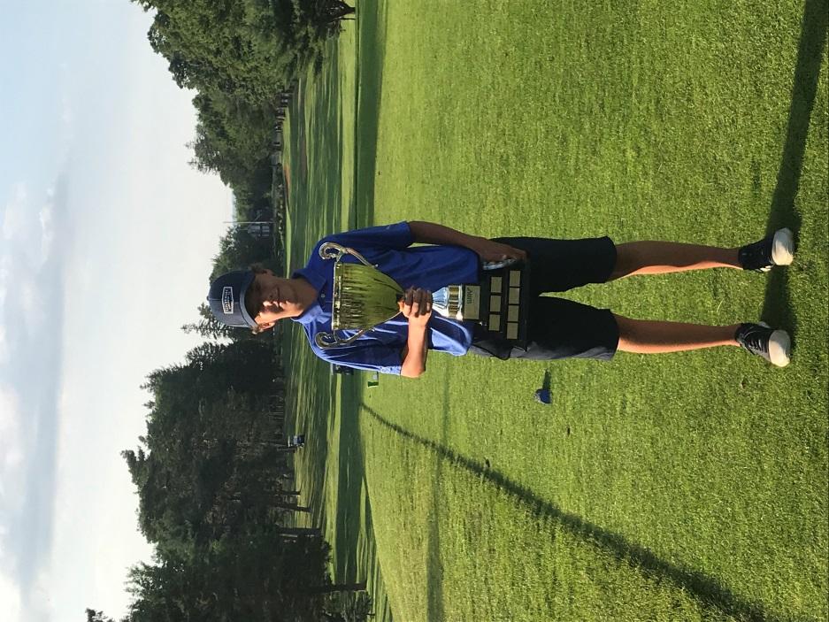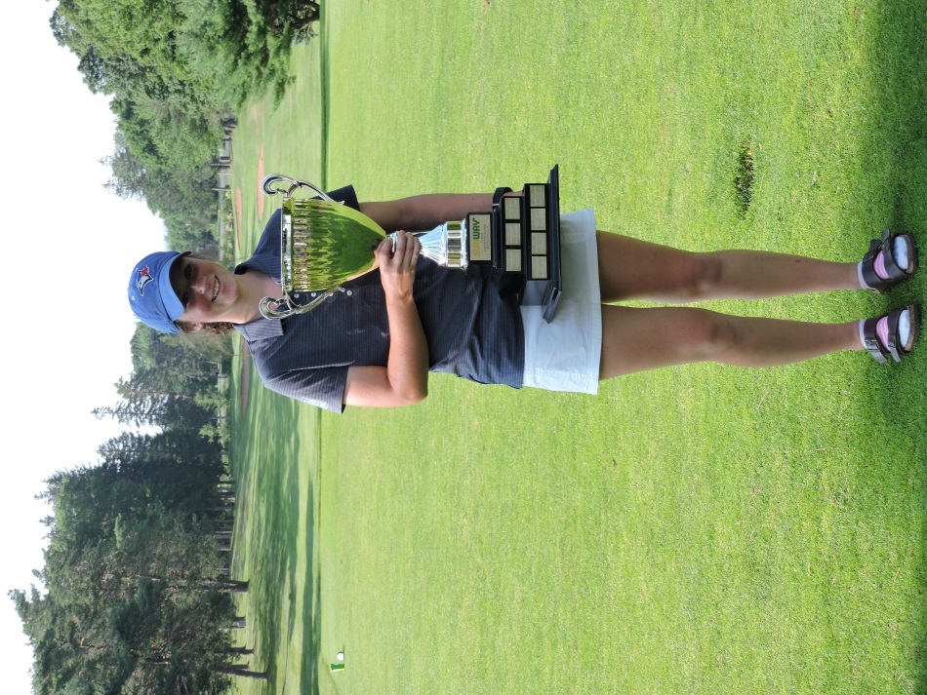
Boys Champion – Jack Shaw, Ken-Wo 71
*wins in playoff!

Girls Champion – Abbie Wamboldt, Northumberland 81 *wins in playoff!

Junior Girls Division

Junior Junior Champion Lauren Rushton, Ken-Wo 84

Juvenile Juvenile Champion Danielle Cumby, Ken-Wo 81
1st Gross Emma Rushton, Ken-Wo 82
1ST Net Claire Tramble, Ashburn 69net

Bantam Bantam Champion Katie MacIntyre , Oakfield 97 1st Gross Nola Marshall, Ken-Wo 110
2nd Gross Kaitlyn Spicer, Brightwood 83net

PeeWee PeeWee Champion Annika PArkash, Ashburn 87
1st Gross Olivia Seaman, Ken-Wo 91
1st Net Avery Cohen, Abercrombie 75net

Novice Novice Champion Claire MacIntyre, Oakfield
1nd Gross Tatum Lohnes, Bluenose
2nd Gross Monica Ennis, Ken-Wo
3rd Gross Ada Barnett, Ken-Wo

Junior Boys Division

Junior Junior Champion Issac MacNaughton, Truro 72
1nd Low Gross Zack Brown, Oakfield 75
2rd Low Gross Eric Foote, Ashburn 78
3rd Low Gross Connor MacKay, Truro 79

Junior 1st Low Net Sam Stoddard, Truro 67net
2nd Low Net Cameron McCulloch, Grandview 71net
3rd Low Net Matthew Schnurr, Oakfield 72net

Juvenile Juvenile Champion Jake Smith, Ashburn 71
1nd Low Gross Benjamin Childs, Ashburn 72
2rd Low Gross Dylan MacLeod, Abercrombie 76
3rd Low Gross Tommy Shaw, Ken-Wo 79
4th low Gross Finn Kimball, Bluenose 80

Juvenile 1st Low Net Owen Sypher, Ken-Wo 67net
2nd Low Net Nathan Eveleigh, Ken-Wo 71net
3rd Low Net Gavin Keating, Brightwood 72net
4th Low Net

Bantam Bantam Champion Jack Shaw, Ken-Wo 71
1nd Low Gross Kien Fudge, Bluenose 78
2rd Low Gross Seamus d’Entremont, West P. 79
3rd Low Gross Nathan Li, Ken-Wo 82
4th low Gross Ryan Frizzle, Oakfield 83

Bantam 1st Low Net Louis Hopper, Oakfield 64net
2nd Low Net Decklin Palmer, Ken-Wo 68net
3rd Low Net Will Denny, Lost Creek 68net
4th Low Net Russ Decoste, Oakfield 69net

Peewee PeeWee Champion Cole MacPhee, Glen Arbour 80
1nd Low Gross Samuel Dixon, River Hills 86
2rd Low Gross Blake Newell, Yarmouth 97
3rd Low Gross Keegan Einsenhauer , Avon V. 99
4th Low Gross Jacob White, Ken-Wo 100

Novice Novice Champion Kooper MacKay, Ken-Wo 53
1nd Low Gross Liam Marshall, Ken-Wo 54
2rd Low Gross Nathan MacDonald, Oakfield 56
3rd Low Gross Grady Cohen, Abercrombie 59
4th Low Gross Jacob Seaman, Ken-Wo 72

1st Low Net Brady Newell, Yarmouth 22net
2nd Low Gross Jacob Seaman, Ken-Wo 33net
3rd Low Gross Rory Coleman-King, Eden 33net

*novice played 13 holes

Team Competition: Each club with a minimum of four players qualify.

Winners:
Ashburn - Jake Smith, 71 – Benjamin Childs, 72 – Eric Foote, 78 – Claire Tramble, 83

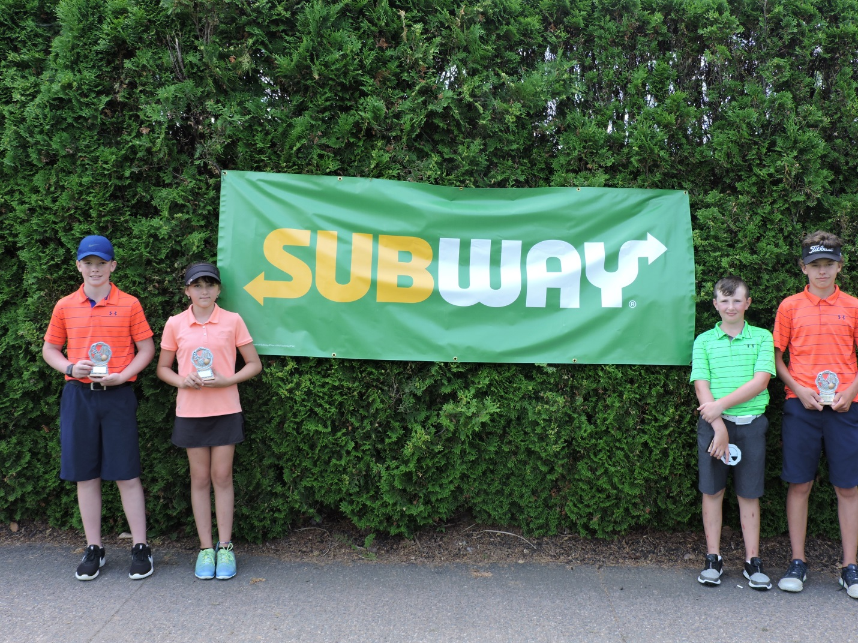
(Peewee Champ – Cole MacPhee, Noice Girls Champ – Claire MacIntyre, Novice Cahmp – Kooper MacKay, Bantam Champ – Jack Shaw)

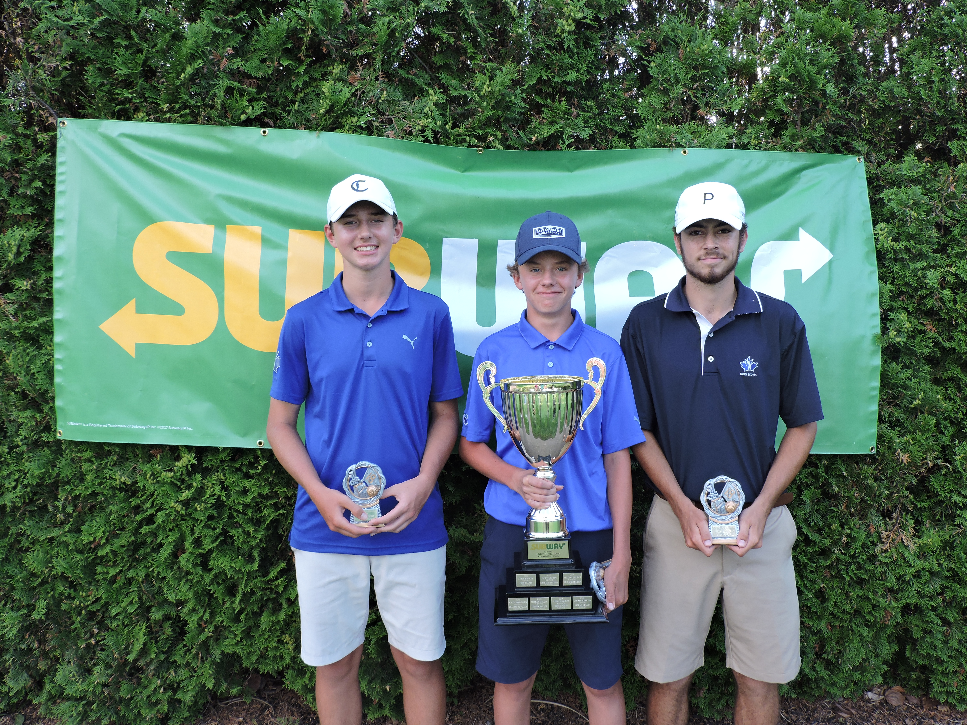
(Juvenile Champ - Jake Smith, Overall Champ - Jack Shaw, Junior Champ - Isaac MacNaughton)
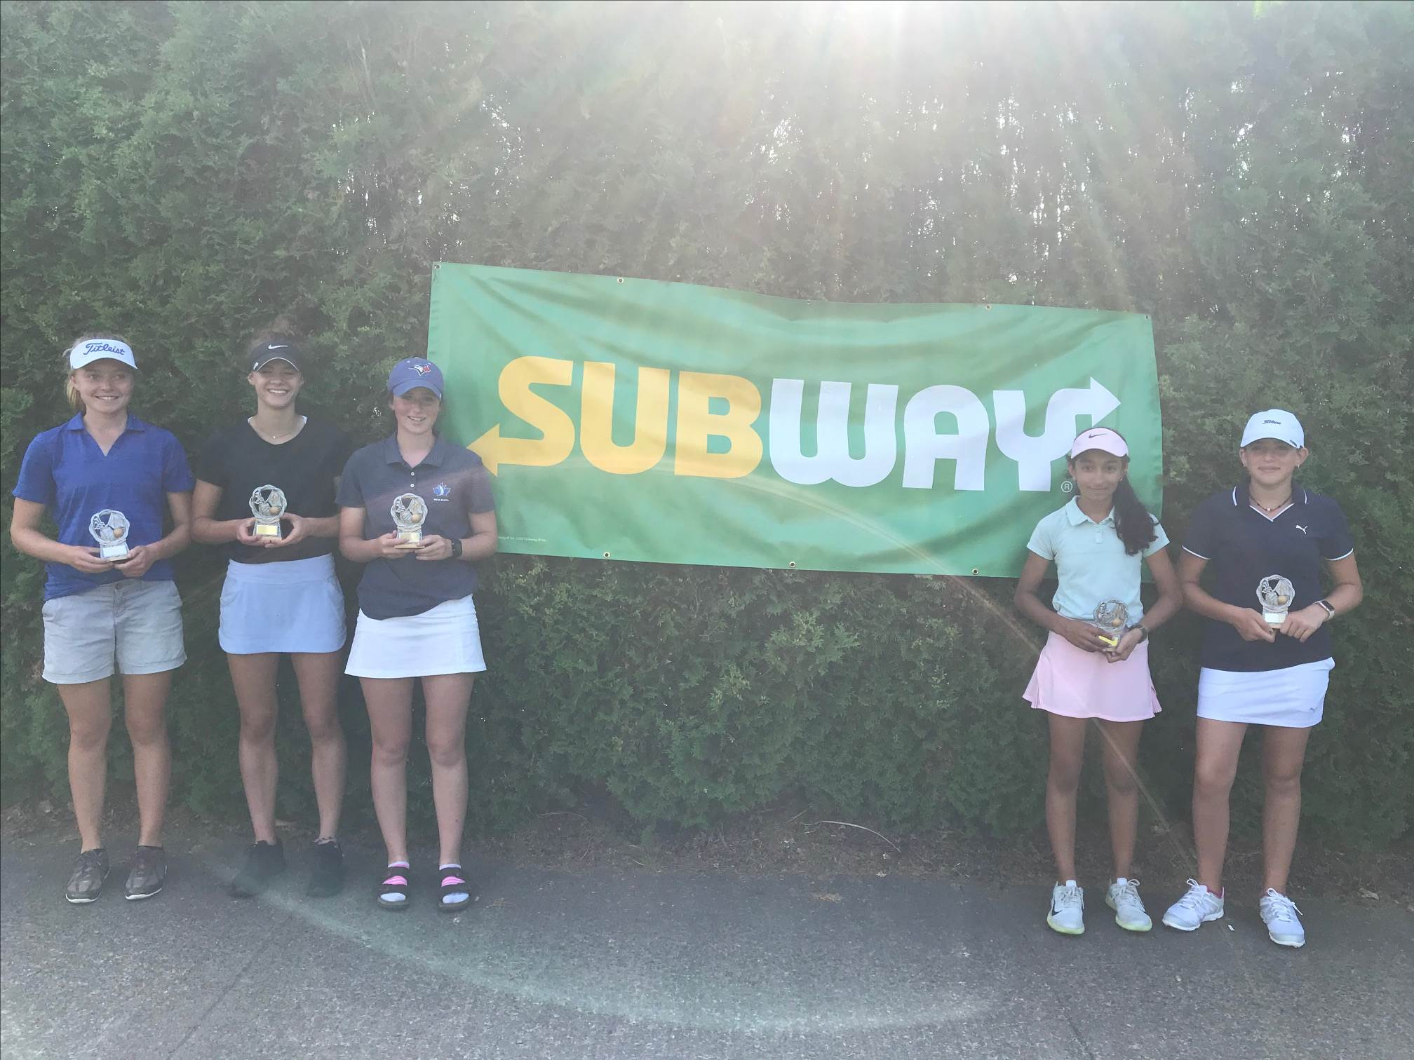
(Junior Girl Champ – Lauren Rushton, Juvenile Girls Champ – Danielle Cumby, Overall Girls Champ – Abbie Wamboldt, Bantam Girls Champ – Katie MacIntyre, Peewee Girls Champ – Annika Parkash)

